**MarketPlace**:

MarketPlace is like an appstore where we place all the developed apps at one place. User can copy the required app from this marketplace.For this basically the developed app has to be added to the marketplace successfully.Once the app is in marketplace user can copy this app to their cloud.

**Screenshots and Scope**:

1)The developed app has to be moved to marketplace.For this all the required information has to be provided.

**a)Display Name**:With which name your app has to be shown in the marketplace

**b)Description**: Any help text required to explain about the app

**c)Documentation link:** The link of a document you want to associate to this app

**d)Logo Url:** Logo for your app is necessary.Url of that logo has to be provided.

**e)Is_Secure,Is_Writable:** Permissions we are providing in order to access the app by end user once they copy it from marketplace.

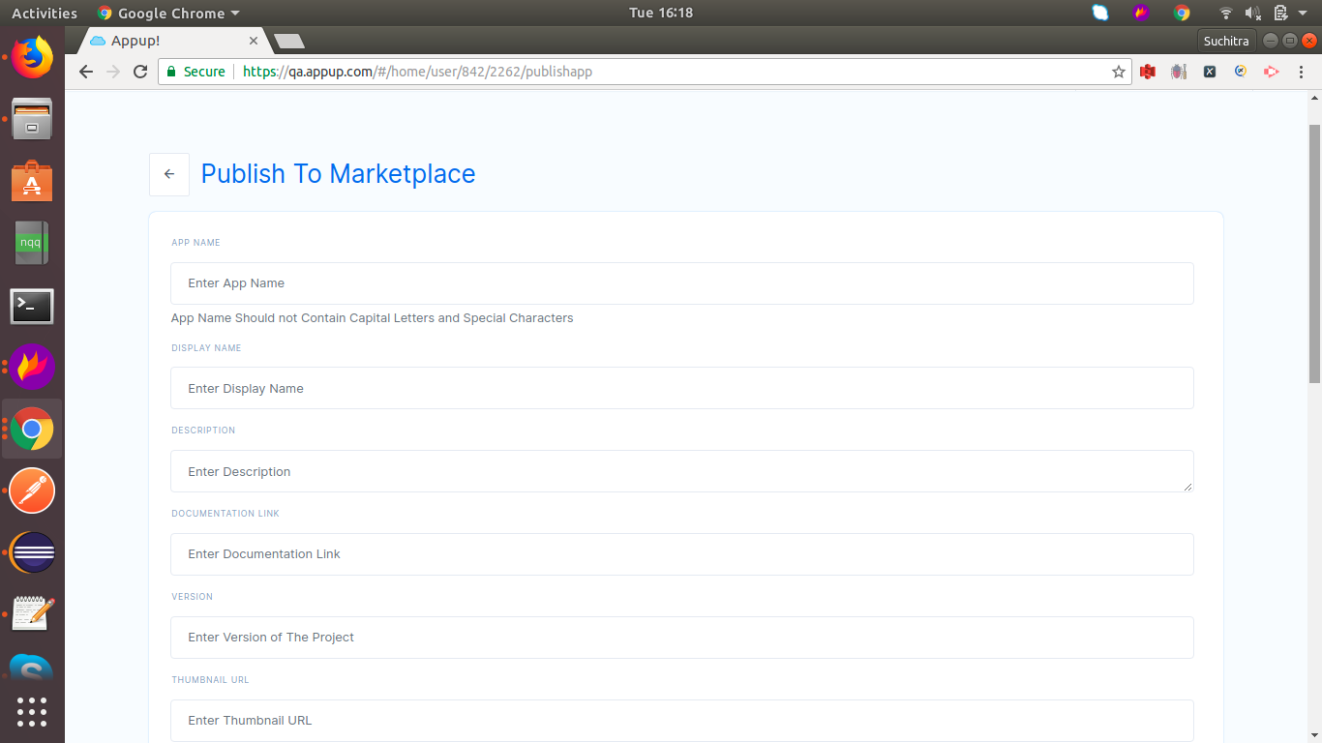

Once all the details are provided click on the ‘Upload to Marketplace’ button in order to place your app in the marketplace.

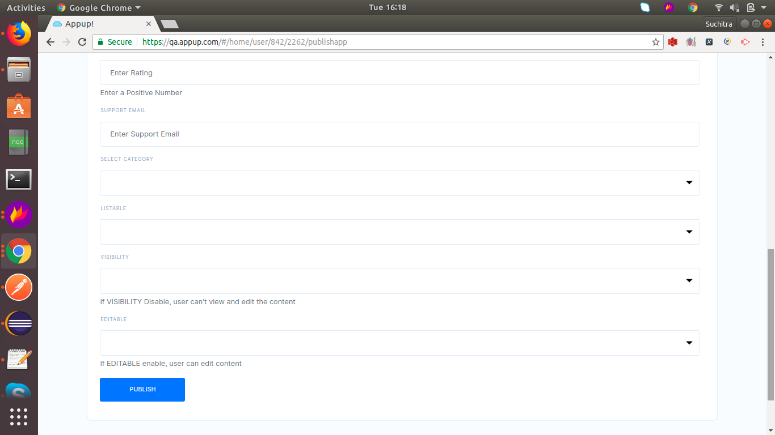

2)To check this app in marketplace,goto ‘Add More Apps’ link and select ‘Get Apps’ link.

3)All apps that are placed in marketplace is shown.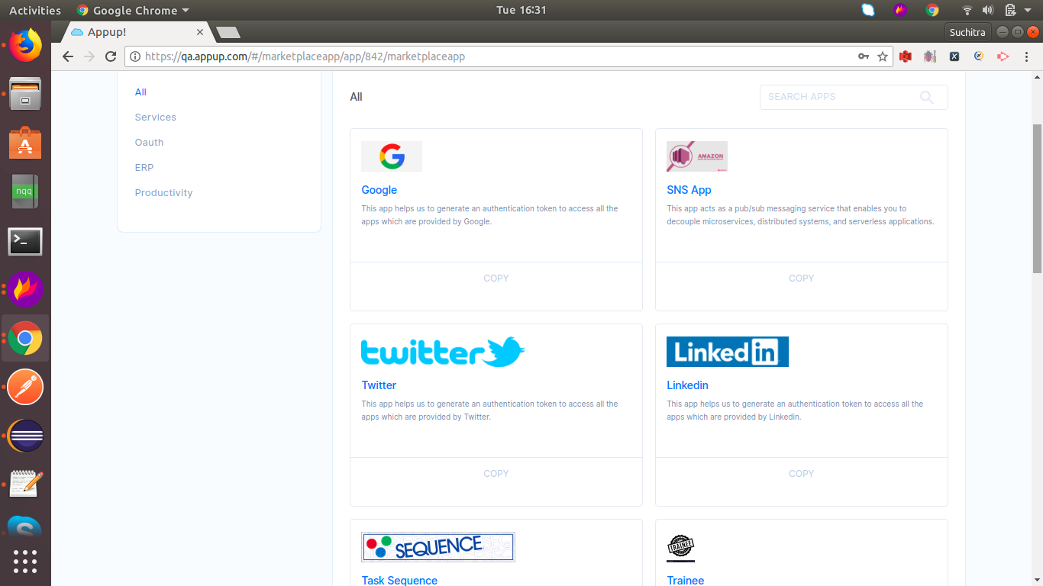

4)Select the app that you want to copy to your cloud by clicking on the ‘Copy’ button.

5)App will get copied to your cloud.